

**UNIVERSITY OF NEW COLUMIA – NEW COLUBIA, ST**

The TRIO Talent Search program at the University of New Columbia serves approximately 1,000 students in grades 9-12 at New Columbia High School and District High School in New Columbia, State. Talent Search provides participants with academic advising, financial aid counseling, standardized test preparation, opportunities for college site visits, and assistance with college and financial aid applications. Our participants come from low-income families across New Columbia in which neither parent has a college degree.

Each year, our program is accountable for meeting specific performance outcomes. This helps guarantee our students success!

In 2015-2016, 97% of non-seniors were promoted to the next grade level.

In 2015-2016, 95% of high school seniors graduated from secondary school.

In 2015-2016, 85% of college-ready participants enrolled in postsecondary education programs.

*“As a first-generation student, I didn’t know the first thing about going to college. But my Talent Search program was there for me every step of the way. I had the opportunity to visit colleges, got help preparing for the SAT and filling out the FAFSA. Thanks to their help, I became the first person in my family to earn a college degree. I am forever grateful!”*

– Nancy S., University of New Columbia, Class of 2016

For more information about the TRIO Talent Search program at the University of

New Columbia, please contact Ima Teacher, Program Director, at [ima.teacher@newcolumbia.edu](mailto:ima.teacher@newcolumbia.edu) or (202) 555-1234.

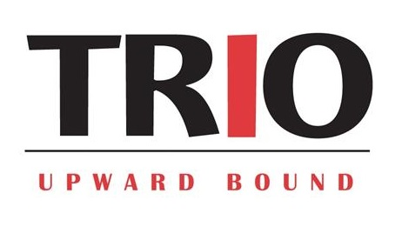

**UNIVERSITY OF NEW COLUMIA – NEW COLUBIA, ST**

The TRIO Upward Bound program at the University of New Columbia serves approximately 150 students from New Columbia High School and District High School in New Columbia, State. Upward Bound provides participants with an intensive academic experience on Saturdays and for six weeks each summer on the campus of the University of New Columbia. The curriculum includes academic instruction, personal mentoring, financial aid counseling, standardized test preparation, opportunities for college site visits, and assistance with college and financial aid applications. Our participants come from low-income families across New Columbia in which neither parent has a college degree.

Each year, our program is accountable for meeting specific performance outcomes. This helps guarantee our students success!

In 2015-2016, 97% of non-seniors were promoted to the next grade level.

In 2015-2016, 95% of high school seniors graduated from secondary school.

In 2015-2016, 85% of college-ready participants enrolled in postsecondary education programs.

By 2016, 75% of former participants earned college degrees within six years of high school graduation.

*“I didn’t know the first thing about going to college. But through Upward Bound I got a taste of the college experience – living on campus and taking classes. I got help preparing for the SAT and filling out the FAFSA. Thanks to Upward Bound, I became the first person in my family to earn a college degree. I am forever grateful!”*

– Nancy S., University of New Columbia, Class of 2016

For more information about the TRIO Talent Search program at the University of

New Columbia, please contact Ima Teacher, Program Director, at [ima.teacher@newcolumbia.edu](mailto:ima.teacher@newcolumbia.edu) or (202) 555-1234.

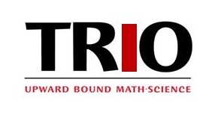

**UNIVERSITY OF NEW COLUMIA – NEW COLUBIA, ST**

The TRIO Upward Bound Math-Science (UMBS) program at the University of New Columbia serves approximately 150 students from New Columbia High School and District High School in New Columbia, State. UBMS provides participants with an intensive academic experience on Saturdays and for six weeks each summer on the campus of the University of New Columbia. Featuring an academic curriculum that focuses on science, technology, engineering, and math (STEM), the program also includes personal mentoring, financial aid counseling, standardized test preparation, and assistance with college and financial aid applications. Our participants come from low-income families across New Columbia in which neither parent has a college degree.

Each year, our program is accountable for meeting specific performance outcomes. This helps guarantee our students success!

In 2015-2016, 97% of non-seniors were promoted to the next grade level.

In 2015-2016, 95% of high school seniors graduated from secondary school.

In 2015-2016, 85% of college-ready participants enrolled in postsecondary education programs.

By 2016, 75% of former participants earned college degrees within six years of high school graduation.

*“I didn’t know the first thing about going to college. But through Upward Bound Math-Science I got a taste of the college experience – living on campus and taking classes. I got help preparing for the SAT and filling out the FAFSA. Thanks to Upward Bound, I’m now a sophomore engineering major at the University of New Columbia!”*

– Nancy S., University of New Columbia, Class of 2019

For more information about the TRIO Talent Search program at the University of

New Columbia, please contact Ima Teacher, Program Director, at [ima.teacher@newcolumbia.edu](mailto:ima.teacher@newcolumbia.edu) or (202) 555-1234.



**UNIVERSITY OF NEW COLUMIA – NEW COLUBIA, ST**

The TRIO Student Support Services (SSS) program at the University of New Columbia serves approximately 300 undergraduates at the University of New Columbia. SSS provides participants with academic instruction, personal mentoring, financial aid counseling, and other supports necessary to ensure that they achieve their goals of earning a postsecondary education. Our participants come from low-income families across in which neither parent has a college degree.

Each year, our program is accountable for meeting specific performance outcomes. This helps guarantee our students success!

In 2015-2016, 87% of first-year students persisted to the next academic year.

In 2015-2016, 76% of eligible participants earned their bachelor’s degree.

*“As a first-generation student, I didn’t know the first thing about how to make it in college. But the staff of my SSS program was there for me every step of the way – building my confidence and offering support when I didn’t think I would succeed. Thanks to their encouragement – and the academic tools they provided – I became the first person in my family to earn a college degree. I am forever grateful!”*

– Nancy S., University of New Columbia, Class of 2016

For more information about the TRIO Talent Search program at the University of

New Columbia, please contact Ima Teacher, Program Director, at [ima.teacher@newcolumbia.edu](mailto:ima.teacher@newcolumbia.edu) or (202) 555-1234.

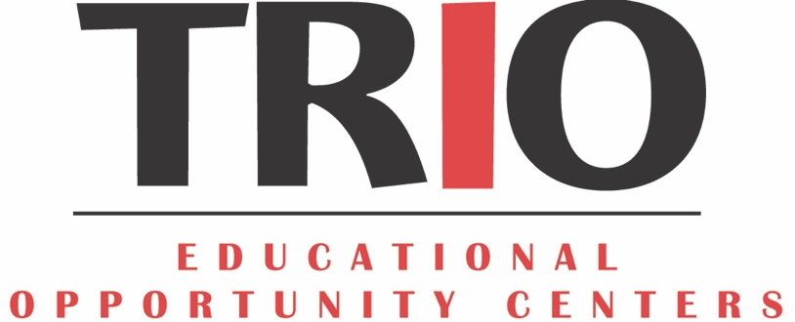

**UNIVERSITY OF NEW COLUMIA – NEW COLUBIA, ST**

The TRIO Educational Opportunity Center (EOC) at the University of New Columbia serves approximately 1,000 low-income adults across New Columbia who desire to re-enter the academic arena. EOC provides counseling and information on college admissions and financial aid. Participants include individuals seeking to earn their high school diplomas as well as those who desire to enter (and possibly return to) postsecondary education programs. Our participants come from low-income families in which neither parent has a college degree.

Each year, our program is accountable for meeting specific performance outcomes. This helps guarantee our students success!

In 2015-2016, 75% of participants without a secondary school diploma enrolled in programs leading to secondary school diploma or its equivalent.

In 2015-2016, 76% of eligible participants enrolled in postsecondary education programs.

*“Having graduated from high school almost 20 years ago, I didn’t know the first thing about applying to college. But the EOC staff at the University of New Columbia was there for me every step of the way – from deciding which college to apply to and figuring out how to pay for it. Thanks to their help, I am now in my second semester!”*

– Nancy S., University of New Columbia, Class of 2016

For more information about the TRIO Talent Search program at the University of

New Columbia, please contact Ima Teacher, Program Director, at [ima.teacher@newcolumbia.edu](mailto:ima.teacher@newcolumbia.edu) or (202) 555-1234.

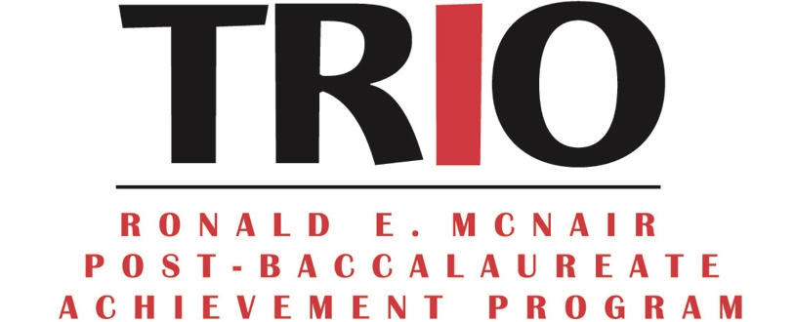

**UNIVERSITY OF NEW COLUMIA – NEW COLUBIA, ST**

The TRIO Ronald E. McNair Postbaccalaureate (McNair) program at the University of New Columbia serves approximately 80 low-income, first-generation, and underrepresented upperclassmen at the University of New Columbia who aspire to pursue doctoral degrees. McNair provides participants with research opportunities, faculty mentoring, and the opportunity to engage in scholarly activities in preparation for postgraduate study.

Each year, our program is accountable for meeting specific performance outcomes. This helps guarantee our students success!

In 2015-2016, 89% of former participants either enrolled or continued to be enrolled in postgraduate education programs.

By 2016, the University of New Columbia has produced more than 50 Ph.Ds.

*“For as long as I can remember, I have wanted to be a college professor. But, for a kid like me – coming from a low-income household in which neither parent finished college – I didn’t know how I would make that dream a reality. The McNair program provided me with the necessary tools to succeed, both academically and professionally. I am now working on my dissertation and still relying on the foundational skills provided by the McNair program.”*

– Nancy S., University of New Columbia, Class of 2012

For more information about the TRIO Talent Search program at the University of

New Columbia, please contact Ima Teacher, Program Director, at [ima.teacher@newcolumbia.edu](mailto:ima.teacher@newcolumbia.edu) or (202) 555-1234.

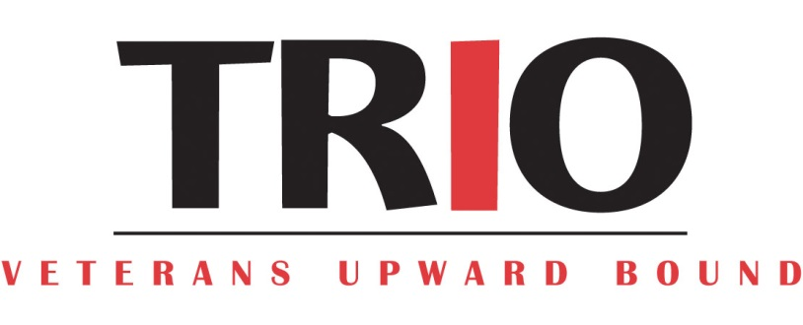

**UNIVERSITY OF NEW COLUMIA – NEW COLUBIA, ST**

The TRIO Veterans Upward Bound (VUB) program at the University of New Columbia serves approximately 125 low-income, first-generation military veterans. VUB provides a unique service to veterans hoping to return to college, aiding them in the transition process through intensive basic skills development and short-term remedial courses. Additionally, participants receive assistance in navigating the services offered by Department of Veterans Affairs, veterans associations, and other veteran support organizations.

Each year, our program is accountable for meeting specific performance outcomes. This helps guarantee our students success!



In 2015-2016, 89% of former participants either enrolled or continued to be enrolled in postsecondary education programs.

*“After completing two tours of duty oversees, I knew that I was ready to pick up where I left off with my education once I returned home. The only problem was that I didn’t know where to begin. I hadn’t been in a classroom in years and I needed a lot of support. The VUB program at the University of New Columbia was there to provide me with the remediation I needed to prepare for the college classroom. I am now in my third year of college and I’m considering continuing on for my Master’s degree. Thank you Veterans Upward Bound!”*

– Nancy S.

For more information about the TRIO Talent Search program at the University of

New Columbia, please contact Ima Teacher, Program Director, at [ima.teacher@newcolumbia.edu](mailto:ima.teacher@newcolumbia.edu) or (202) 555-1234.