EXAMPLES OF TRIO ADVOCACY FROM ACROSS THE COMMUNITY
Specific examples of TRIO students and staff making the most of opportunities to promote TRIO!
SPOTLIGHT: IOWA
Director of Talent Search Erica Frey and Valerie White hosted Senator Joni Ernst at Southwestern Community College in Iowa. Student, Abbe Baumfalk, shared how she learned about TRIO and the resources TRIO provides to help students overcome class, social, and cultural barriers. TRIO helped her find the money for college, including this $1,000 scholarship from Southwestern.
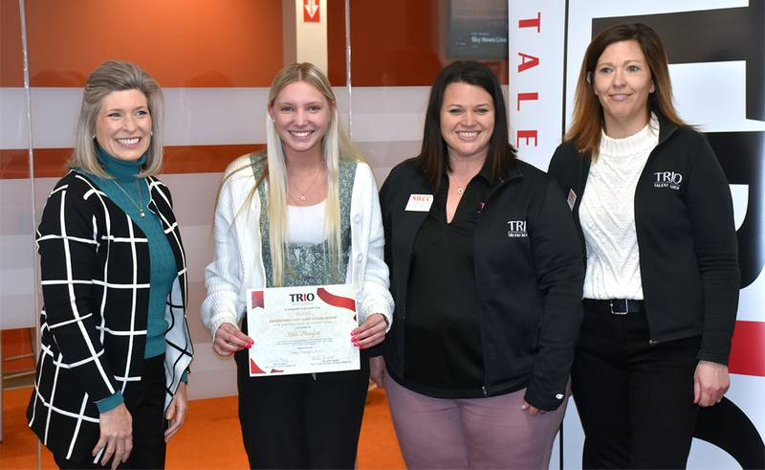
SPOTLIGHT: CALIFORNIA
Horacio Aceves, Assistant Director of the Upward Bound program at Occidental College, invited Congressman Jimmy Gomez (CA-34) to visit campus and meet students. During the meeting, Congressman Gomez pledged to support TRIO funding. The Congressman tweeted a picture of his visit to his thousands of followers!
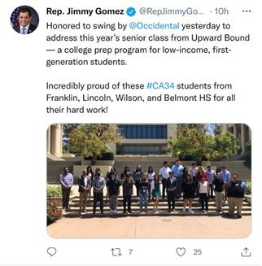
These are just a handful of examples of advocacy happening across the country! Please inform the Government Relations team of your efforts by contacting Zach Farmer via e-mail at zach.farmer@coenet.org or phone at (202) 347-7430.
*NOTE: The Council for Opportunity in Education is a non-profit, non-partisan organization and, as such, does not endorse any candidates or political parties. The abovementioned piece is for informational purposes and should not be construed otherwise.

