Congressional
Summer Recess
Packet
2022
June 30, 2022
Dear TRIO Colleagues:
As you know, the House Appropriations Committee just passed legislation that, if mirrored by the Senate and signed by the President, would provide TRIO with a $161 million funding increase in FY 2023 (The program Year 2023-2024). Not only would this provide enough funding to award an inflationary increase to existing projects, but it would also provide sufficient funds to fund high-scoring grants in the most recent TRIO grant competitions!
Therefore, over the next several weeks, TRIO personnel, students, parents, alumni, and other supporters must demonstrate that TRIO Works! To do this, we must make our voices heard. This midterm election provides a unique opportunity to engage with your federal officials. During their first midterm election cycles, the last four presidents lost their majority in the House and Senate. With Congress up for grabs, Members of Congress want to meet with students and their families on the campaign trail. COE is challenging the TRIO community to host as many local visits with your Representatives and Senators as possible while they are back home in their States and Districts for the Summer Congressional Recess.
House Recess: Saturday, July 30 to Monday, September 5
Senate Recess: Saturday, August 6 to Monday, September 5
To help you achieve this goal, this Summer Recess Packet includes the following:
- Simple steps to host a congressional visit and allow your Member of Congress to see TRIO programs and students in action (Page 3)
- Sample in-person meeting request (Page 4)
- Lobby Visit Roadmap (Page 5)
- Examples of outreach efforts by the TRIO Community (Page 6-7)
We encourage you to take advantage of the resources in this Summer Congressional Recess Packet and to use the contact information for all congressional education staffers and schedulers by state and district. Let us know if you are planning or have already met with your Members of Congress so we can highlight your advocacy! Just send a short report including your name, title, TRIO program, state, type of meeting (site visit, one-on-one, townhall), and the name of the Representative or Senator to zach.farmer@coenet.org.
Let's remind your Members of Congress that TRIO WORKS!

TURN YOUR MEMBER OF CONGRESS INTO A TRIO CHAMPION AT HOME!
Simple steps to host a congressional visit and allow your Member of Congress to see TRIO programs and students in action!
PLANNING THE VISIT
- Talk to your institution's Government Relations/Public Affairs Office about inviting your Member of Congress to Campus. Involve your institutional officers to ensure campus buy-in and support your idea. Quite often, they will want to assist in the planning to ensure a successful visit by your Member of Congress.
- Find out when your Member of Congress is available to visit. Be flexible. Members of Congress' schedules fill up quickly while at home. Take care to plan your event based on the legislator's availability. Contact your legislator's congressional scheduler to determine when your Member of Congress might be available to visit. (COE can help with this, too!)
- Send an official invitation to your Member of Congress. E-mail a letter inviting your Member of Congress to visit. (A sample letter is available below.) Find the contact information for your Members of Congress's scheduler and legislative education assistants here, Congressional Contact Info. COE can also assist you in following up with the legislator's Washington, D.C. office.
- Follow up, follow up, follow up! If you haven't heard back in a few days – a week at most – be sure to follow up on your request to finalize a time and date for the big day!
DURING THE VISIT
- TRIO, TRIO, Everywhere TRIO! Be sure to outfit all students in TRIO with hats, pins, stickers, or shirts. You may even want to present the Member of Congress with their own "TRIO Works" button!
- Make the Member of Congress feel welcome. Be sure to have students greet your legislator when they arrive on campus and escort them to the day's event site. You may even wish to have the students prepare signs or a banner to welcome your guest to the program. Also, legislators often bring their staff members to accompany them to such events. Be sure to treat them with the same respect as the legislators themselves—the staff often plays a critical role in whether a legislator supports an issue or not!
- Have a plan. Craft a formal program agenda that prioritizes the legislator's time. Ideally, the Member of Congress should speak first. The program should also include remarks by any institutional officials and program participants.
- Showcase students and alumni. Now is the time to let your students and their stories shine! Hand-pick student and alumni representatives to share testimonials about their experience in TRIO. Be sure to limit each student to two to five minutes. If possible, allow time for the Member of Congress to speak directly with the students and alumni.
AFTER THE VISIT
- Publicize the event. Share pictures from the event with COE and social media using the hashtag #TRIOWorks. Be sure to "tag" your Member of Congress on social media and thank them for visiting.
- Send a thank you letter. Be sure to send a follow-up letter thanking your Member of Congress for taking the time to visit your program. (You may even want to have students handwrite thank you notes for the legislator.) Including pictures from the event with your message(s) would be fantastic.
- Share any media coverage with COE. Let us highlight and celebrate your work! We will feature your efforts in our Weekly newsletter and on social media outlets.
- Keep the relationship going! After a successful visit, maintain contact with your Member of Congress and their staff. Provide the office periodic updates on student successes and other events at your program. Remember, it's better to make a friend before you need a friend!

SAMPLE IN-PERSON MEETING REQUEST LETTER

[INSERT DATE]
The Honorable [SENATOR OR REPRESENTATIVE NAME]
U.S. [SENATE] or [HOUSE OF REPRESENTATIVES] [ADDRESS]
Attn: [SCHEDULER NAME] and [EDUCATION LEGISLATIVE ASSISTANT NAME]
Dear [SENATOR OR REPRESENTATIVE NAME]:
My name is [NAME], and I am the [TITLE] for the [TRIO PROGRAM] at [INSTITUTION]. Over the years, we have had many students come through our program and go on to earn college degrees. I would very much like to invite [SENATOR/REPRESENTATIVE NAME] to visit our [TRIO PROGRAM] program at [INSTITUTION] sometime this summer so that you can meet our students and learn about the impact of this program on their lives.
Since [YEAR], we have been serving students through [TRIO PROGRAM] at [INSTITUTION], and we know our current students would be honored to meet you or a member of your staff.
Please let us know when you might be able to visit our students sometime this summer. They are on campus through [END DATE OF SUMMER PROGRAM]. We are happy to work with your staff to identify a time that would work best for your schedule. I appreciate your consideration of this request.
Sincerely,
[Name, National/Regional/State TRIO leadership title, Institution title, Institution, location]

2022 LOBBY VISIT ROADMAP AND AGENDA
1. Introduce yourselves. Starting with the Team Leader (or their designated representative), begin a round of introductions. Share who you are and your relevant TRIO affiliation (e.g., "My name is Jim Smith, and I'm the Director of the Educational Opportunity Program hosted by New State University.").
2. Say "thank you." The Team Leader (or their designated representative) should thank the legislator and their staff for taking the time to meet. Also, if a Member of Congress is a supporter, thank the legislator and their staff for their past help on TRIO issues. Look up whether your Members of Congress signed onto the annual TRIO funding letter here, House signers and Senate signers.
3. Introduce or refresh TRIO. If you are meeting with a new Member of Congress or a new congressional staffer who is unfamiliar with TRIO, take a few moments to explain how TRIO works on your campus/in your community to increase college access and success for low-income, first-generation students. Even experienced staffers could use a refresher, especially with district and state-level data.
4. Tell your stories. Designated team members will offer stories about the impact of TRIO and the new challenges low-income students are facing in a post-pandemic learning environment.
5. TRIO students graduate! Share with the legislator or staffer that a new report commissioned by the U.S. Department of Education is only the latest to show that TRIO students persist, complete credits, and graduate at higher rates than nonparticipants with similar characteristics. This factsheet highlights TRIO results.
6. Make the Ask. The Team Leader (or their designated representative) should explain that you are here to request that the Member of Congress:
- Support a funding increase for TRIO in FY 2023. Explain that the increase of $161 million in FY 2023 will help meet the need for an increase in TRIO services post-pandemic. This historic increase could serve nearly 1 million students next year.
- Request language to 'fund down the slate' for the FY22 TRIO grant competitions. Appropriators in Congress must include this language in the final funding bill sent to President Biden. This language will allow the Secretary to fund the high-scoring FY22 Upward Bound, Upward Bound Math-Science, Veterans Upward Bound, and McNair applications that fall slightly below the cutoff score.
7. Respond to follow-up questions and listen. Ask for and listen to responses to your request.
8. Share hard copies of information. If meeting in person, the designated team member should give copies of information about TRIO in the State/District, program-level data, and any other handouts to the congressional staff (NOT the legislator). Highlight any program-specific information you have.
9. Express thanks. The Team Leader (or their designated representative) should thank the legislator or staffer for taking the time to meet.
10. Follow up with the staff. The Team Leader (or their designated representative) should follow up with an e-mail to the staff that includes (1) another thanks for the meeting, (2) electronic copies of all materials, and (3) an inquiry as to when the legislator or staff would be able to visit a program within the next six months. (You should send this follow-up message within three days.)

EXAMPLES OF TRIO ADVOCACY FROM ACROSS THE COMMUNITY
Specific examples of TRIO students and staff making the most of opportunities to promote TRIO!
SPOTLIGHT: IOWA
Director of Talent Search Erica Frey and Valerie White hosted Senator Joni Ernst at Southwestern Community College in Iowa. Student, Abbe Baumfalk, shared how she learned about TRIO and the resources TRIO provides to help students overcome class, social, and cultural barriers. TRIO helped her find the money for college, including this $1,000 scholarship from Southwestern.
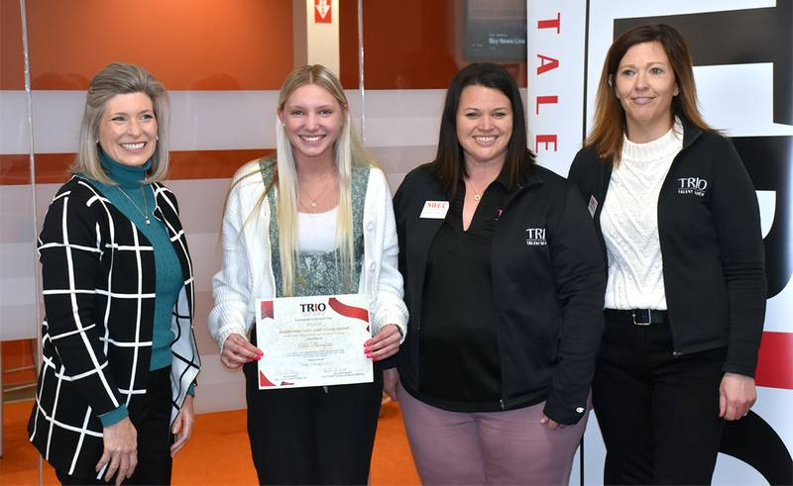
SPOTLIGHT: CALIFORNIA
Horacio Aceves, Assistant Director of the Upward Bound program at Occidental College, invited Congressman Jimmy Gomez (CA-34) to visit campus and meet students. During the meeting, Congressman Gomez pledged to support TRIO funding. The Congressman tweeted a picture of his visit to his thousands of followers!
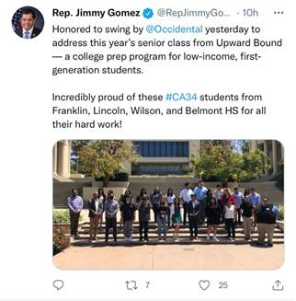
These are just a handful of examples of advocacy happening across the country! Please inform the Government Relations team of your efforts by contacting Zach Farmer via e-mail at zach.farmer@coenet.org or phone at (202) 347-7430.
*NOTE: The Council for Opportunity in Education is a non-profit, non-partisan organization and, as such, does not endorse any candidates or political parties. The abovementioned piece is for informational purposes and should not be construed otherwise.

