

|  |  |
| --- | --- |
| TABLE OF CONTENTS | |
| INTRODUCTION | Pg. 2 |
| [INSERT STATE] TRIO PROGRAMS | Pg. 3 |
| [INSERT STATE] TRIO PROGRAMS DATA | Pg. 5 |
| MAP OF TRIO PROGRAMS IN [INSERT STATE] | Pg. 6 |
| TRIO BY CONGRESSIONAL DISTRICT | Pg. 7 |
| [INSERT STATE] TRIO STUDENT and Alumni STORIES | Pg. 8 |
| [INSERT STATE] TRIO Association Leaders | Pg. 10 |
| Examples from other State factbooks | Pg. 11 |
| Links to other STATEs and contacts | Pg. 18 |

# [INSERT STATE] TRIO ASSOCIATION

WHAT IS TRIO?

*(PERSONALIZE IMAGE(S)/COULD USE MULTIPLE)*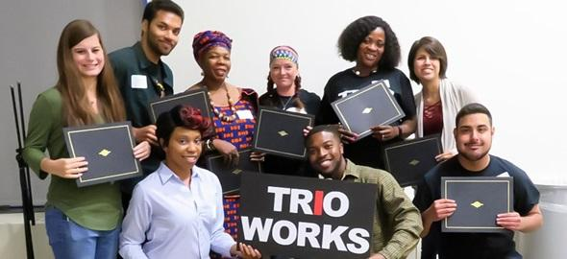

*Here, give an overview of TRIO and its goals nationally and in your state. Why does TRIO exist?*

*How does TRIO help on a nationwide level and in your state?*

EXAMPLE:

TRIO is a network of federally supported college opportunity programs that encourage and support students from disadvantaged backgrounds to pursue a college education. Over 3,100 programs nationwide assist more than 800,000 low-income, first-generation students and students with disabilities, from sixth grade through college graduation. TRIO programs offer academic tutoring, personal counseling, mentorship, financial guidance, and other services to aid students in educational access and retention.

TRIO programs were the first national college access and retention initiatives in the United States to address severe social and cultural hurdles to learning. TRIO was established as part of Lyndon B. Johnson's War on Poverty. Upward Bound was developed by the Educational Opportunity Act of 1964 as an experimental program. The Higher Education Act of 1965 then established Talent Search. Finally, in 1968, the Special Services for Disadvantaged Students (later known as Student Support Services) project was introduced. This "trio" of federally funded initiatives helped low-income students gain entry to higher education. Educational Opportunity Centers and Veterans Upward Bound were added in 1972, the Ronald E. McNair Post-Baccalaureate Achievement Program in 1986, and Upward Bound Math/Science in 1990.

Two-thirds of the students served by each program must come from homes with earnings of 150 percent or less of the federal poverty threshold, with neither parent having completed college, as stipulated by Congress. More than 1,000 colleges, universities, community colleges, and agencies now offer TRIO Programs in the U.S. and its territories. TRIO funds are distributed to institutions and agencies through competitive 5-year grants.

# [INSERT STATE] TRIO PROGRAMS

DESCRIBE WHAT EACH APPLICABLE PROGRAM DOES & WHO IT SERVES (Ages/grade-levels) BE SURE TO TOUCH ON THE GOALS OF EACH PROGRAM [For a national fact sheet on each program, click here](https://drive.google.com/file/d/13ZNfc-LVTnqSAd8vBPjNRjwV14QyNiGp/view).

UPWARD BOUND (UB)

Population Served:

Students in grades 9-12 who qualify as low-income or potentially first-generation college students.

Services Offered:

Academic year weekly services and a six-week summer program. Services include academic instruction in math, science, composition, literature, and foreign language, tutoring and mentoring, academic, financial, and personal counseling, assistance completing college & financial aid applications, and career exploration.

UPWARD BOUND MATH & SCIENCE

Population Served:

Students in grades 9-12 who qualify as low-income or potential first-generation college students who have an interest in pursuing careers in STEM.

Services Offered:

Summer programs consist of intensive math and science training, year-round counseling and advising, computer training, exposure to university faculty who perform research in math and science, scientific research conducted under the guidance of a faculty or graduate student mentor. Tutoring and mentoring, academic, financial, and personal counseling, assistance completing college and financial aid applications, and career exploration.

VETERANS UPWARD BOUND

Population Served:

Veterans who meet military service requirements stipulated in the authorizing statute and who are low-income, prospective first-generation college students preparing to enter a postsecondary institution.

Services Offered:

Intensive basic skills development for GED completion, refresher classes for subjects required in college, academic, financial, and personal counseling, tutoring services, and assistance completing college and financial aid applications.



# [INSERT STATE] TRIO PROGRAMS

EDUCATIONAL OPPORTUNITY CENTERS

Population Served:

Adults 19 years or older pursuing postsecondary education as first-generation and low-income students.

Services Offered:

Academic advising, personal counseling, career workshops, college application assistance & test preparation, and financial & economic literacy education.

MCNAIR SCHOLARS PROGRAM

Population Served:

Undergraduate students who qualify as low-income, first-generation, and/or underrepresented populations in their field of interest who wish to pursue graduate education.

Services Offered:

Opportunities for mentorship & scholarly activities, summer research internship, seminars & workshops to prepare students for graduate study, and assistance with graduate school admissions processes.

STUDENT SUPPORT SERVICES

Population Served:

Undergraduate students who are low-income, prospective first-generation college students or students with disabilities.

Services Offered:

Intensive academic, financial, and personal counseling, tutoring services, and assistance completing college and financial aid applications.

TALENT SEARCH

Population Served:

Students in grades 6-12 and adults up to age 27 pursuing post-secondary education who qualify as low-income or potential first-generation college students.

Services Offered:

Academic, financial, and career counseling, exposure to college campuses, tutoring services, assistance in completing the college admissions process, and publicizing and assisting with financial aid applications.

# [INSERT STATE] TRIO PROGRAM DATA

(20XX-20XX)

Try to compile statewide statistics from your programs, if possible. You can use the data each program already provides for the Annual Performance Reports.

|  |  |
| --- | --- |
| Educational Talent Search | |
| Total Students | X |
| Low-Income & First-Generation Students (LIFG) | X |
| Rate of Non-Senior Students Persisting to the Next Grade Level | X% |
| Rate of Seniors Completing FAFSA | X% |
| Rate of Seniors Graduating with Rigorous Curriculum | X% |
| High School Graduation Rate | X% |
| College Enrollment Rate | X% |

|  |  |
| --- | --- |
| Educational Opportunity Centers | |
| Total Students | X |
| Low-Income & First-Generation Students (LIFG) | X |
| Rate of Students Completing FAFSA | X% |
| Rate of Students Applying for College | X% |
| Rate of Students Enrolling in College | X% |

|  |  |
| --- | --- |
| Upward Bound | |
| Total Students | X |
| Low-Income & First-Generation Students (LIFG) | X |
| Benchmark Completion Rate | X% |
| Rate of Seniors Graduating with Rigorous Curriculum | X% |
| High School Graduation Rate | X% |
| College Enrollment Rate | X% |
| Rate of 2013-14 Cohort College Enrollees Graduating in 6 years | X% |

|  |  |
| --- | --- |
| McNair | |
| Total Students | X |
| Low-Income & First-Generation Students (LIFG) | X |
| Rate of Students Completing Research/ Other Scholarly Activities | X% |
| Graduate School Enrollment Rate | X% |
| Continued Enrollment in Graduate School Rate | X% |
| Doctoral Degree Attainment | X% |

|  |  |
| --- | --- |
| Student Support Services | |
| Total Students | X |
| Low-Income & First-Generation Students (LIFG) | X% |
| College Retention Rate | X% |
| Graduation Rate | X% |
| Graduates Transferring | X |

# MAP OF Illinois TRIO PROGRAMS

Map of Illinois TRIO projects by congressional district, program year 2020-21

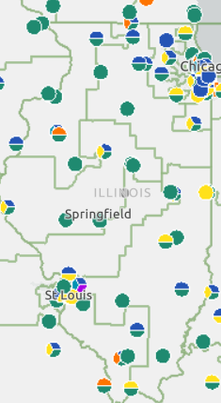

Source: U.S. Department of Education, [TRIO Project Explorer](https://ope.ed.gov/programs/trio/trioexplorer/) (Program Year 2020-21)



|  |  |  |  |  |
| --- | --- | --- | --- | --- |
| CONGRESSIONAL DISTRICT | INSTITUTION | PROGRAM | # OF STUDENTS | FY 20XX FUNDING |
| 1 | X | X | X | X |
| 2 | X | X | X | X |
| 3 | X | X | X | X |
| 4 | X | X | X | X |
| 5 | X | X | X | X |
| 6 | X | X | X | X |
| 7 | X | X | X | X |
| 8 | X | X | X | X |
| 9 | X | X | X | X |
| 10 | X | X | X | X |
|  | X TOTAL | X PROGRAMS | X STUDENTS | $ XXX, XXX |

# [INSERT STATE] TRIO STUDENT AND ALUMNI STORIES

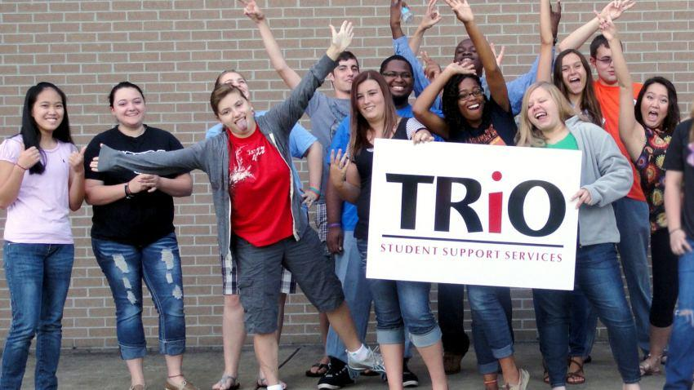

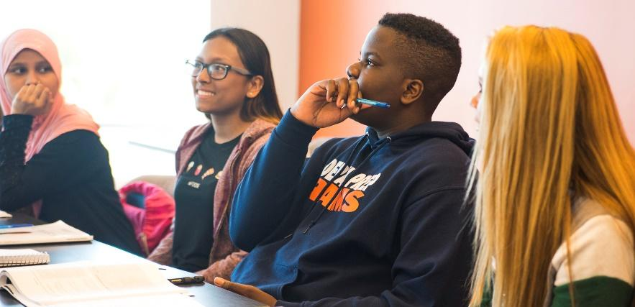

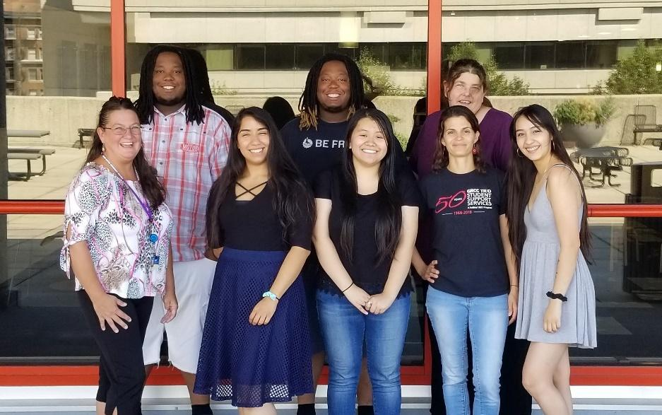

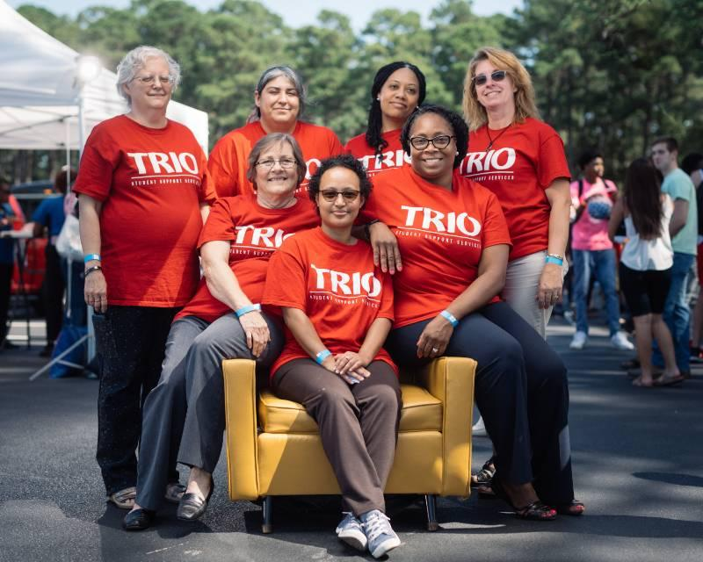

# [INSERT STATE] TRIO STUDENT AND ALUMNI STORIES

Include student/alumni photos and brief stories or quotes, ideally with at least one per district. Include students from a variety of TRIO programs and geographical areas.

District X (if you have at least one story per district, or else statewide…)









# [INSERT STATE] TRIO ASSOCIATION BOARD OF DIRECTORS: CONTACT INFORMATION

|  |  |  |  |  |
| --- | --- | --- | --- | --- |
| TITLE | INSTITUTION | PROGRAM | | EMAIL |
| President | X | X | X | |
| Past President | X | X | X | |
| Secretary | X | X | X | |
| Treasurer | X | X | X | |
| District 1 | X | X | X | |
| District 2 | X | X | X | |
| Technology Specialist | X | X | X | |
| Alumni Relations Partner | X | X | X | |
| Government Relations | X | X | X | |

# EXAMPLES

Note: If possible, try to also add some benchmark data for other low-income students in the state, showing how TRIO has stronger results for key outcome measures.

[Oregon TRIO Program Outcome Data](https://oregontrio.org/)!

TRIO statewide outcome data from [Idaho TRIO](https://idahoatp.org/wp-content/uploads/sites/4/2021/03/2021-IATP-Factbook.pdf)!

Data by institution from [South Dakota TRIO](https://aspireonline.org/wp-content/uploads/sites/5/2017/03/Factbook-2017-Final.pdf)!

Student Stories separated by Congressional District from [Wisconsin TRIO](https://s3.amazonaws.com/ClubExpressClubFiles/254413/documents/Factbook_2021_695328773.pdf?AWSAccessKeyId=AKIA6MYUE6DNNNCCDT4J&Expires=1636562377&response-content-disposition=inline%3B%20filename%3DFactbook_2021.pdf&Signature=VvjSqJ77oMIlixuQKqF30bwBxL0%3D)!

Example of a map showing all TRIO programs by congressional district from [Indiana TRIO](http://indianatrio.org/Resources/Factbook)!

Example from New York State with a map and chart of TRIO programs for greater NYC region

Example from New York State on Individual District Data

# DIRECTORY OF TRIO STATE ASSOCIATION WEBSITES, ONLINE STATE FACTBOOKS, AND TRIO STATE LEADERS

***Are we missing your most recent fact book, website, or state president’s info? Please [share the link to your latest version in this google form here](https://docs.google.com/forms/d/e/1FAIpQLSc9YYhRgTXCeIumvuxvdg4RKmLfINXjTBd9ik5786xg_8kLBg/viewform). Is the State Leader out of date? Contact [Jennifer.Rudolph@coenet.org](mailto:Jennifer.Rudolph@coenet.org)

|  |  |  |  |  |  |
| --- | --- | --- | --- | --- | --- |
| State | State Website | State Factbook | TRIO State Leader | | State Leader Email |
| AK | [Alaska Website](https://alaskatrio.org/home/) | [Alaska Factbook](https://alaskatrio.org/wp-content/uploads/sites/5/2017/06/2016-17-AK-TRIO-Fact-Book.pdf) | Jessica Delgado | | [jpdelgado@alaska.edu](mailto:jpdelgado@alaska.edu) |
| AL | [Alabama Website](http://www.aaeopp.com/index.html) | N/A | Cody Hammack | | [cody.hammack@bscc.edu](mailto:cody.hammack@bscc.edu) |
| AR | [Arkansas Website](http://www.arkansastrio.org/) | [Arkansas Factbook](https://static1.squarespace.com/static/5488631be4b0a0b35b61da6b/t/5abe48221ae6cfebc68fedca/1522419748198/2018+Arkansas+TRIO+Fact+Book.pdf) | Desarae Nelson | | [dxnelson1@ualr.edu](mailto:dxnelson1@ualr.edu) |
| AZ | [Arizona](https://arizona.westop.org/) Website | [Arizona Factbook](https://13212b20-9d43-03a2-e1e5-8ccd6eb4f29b.filesusr.com/ugd/f904a2_528bf68b59f24d4894805882417e0437.pdf) | Nilda Iniguez | | [nilda.iniguez@asu.edu](mailto:nilda.iniguez@asu.edu) |
| CA-C | [Central California Website](http://www.westopcencal.org/) | [California Factbook](http://nebula.wsimg.com/e4117bf35c00e88e0c9392f3893ede8b?AccessKeyId=60097AB2D9C2E7D1E74F&disposition=0&alloworigin=1) | Mike Osorio | | [michael.osorio@evc.edu](mailto:michael.osorio@evc.edu) |
| CA-S | [Southern California Website](http://www.westopsocal.org/home.html) | [California Factbook](http://nebula.wsimg.com/e4117bf35c00e88e0c9392f3893ede8b?AccessKeyId=60097AB2D9C2E7D1E74F&disposition=0&alloworigin=1) | Horacio Aceves | | [socalchapterpres@westop.org](mailto:socalchapterpres@westop.org) |
| CA-N | [Northern California Website](http://www.westopnorcal.org/home.html) | [California Factbook](http://nebula.wsimg.com/e4117bf35c00e88e0c9392f3893ede8b?AccessKeyId=60097AB2D9C2E7D1E74F&disposition=0&alloworigin=1) | Keyanna Hatcher | | [norcalchapterpres@westop.org](mailto:norcalchapterpres@westop.org) |
| CO | [Colorado Website](https://aspireonline.org/colorado/home/about/) | [Colorado Factbook](https://aspireonline.org/colorado/wp-content/uploads/sites/6/2021/04/2021-Factbook.pdf) | Dariana Roybal | | [dariana.roybal@csupueblo.edu](mailto:dariana.roybal@csupueblo.edu) |
| CT | [Connecticut Website](https://www.neoaonline.org/n_links.php) | N/A | Rob Pote | | [poter@wcsu.edu](mailto:poter@wcsu.edu) |
| DC | [DC Website](http://meaeopp.org/wordpress/) | N/A | Janeale Gottlieb-George | | [jggeorge@gwu.edu](mailto:jggeorge@gwu.edu) |
| DE | [Delaware Website](https://destatetrio.wordpress.com/) | N/A | Da’Shon Jones |  | [djone188@dtcc.edu](mailto:djone188@dtcc.edu) |
| FL | [Florida Website](https://fltrio.weebly.com/join.html) | N/A | Rowina Petion | | [harmonr@palmbeachstate.edu](mailto:harmonr@palmbeachstate.edu) |
| GA | [Georgia Website](https://www.georgiatrio.com/) | [Georgia Factbook](https://85550316-de9c-452b-bb4f-405b03fb06c1.filesusr.com/ugd/5a4d3e_ea6eb91bda2d4b62af9d2294bc0f7850.pdf) | Sonia Davis | | [sdbrad@uga.edu](mailto:sdbrad@uga.edu) |
| HI | [Hawaii Website](https://pacificislands.westop.org/) | N/A | James Oda | | James.Oda@gmail.com |
| IA | [Iowa Website](https://sites.google.com/eoa.org/iowatrio/home?authuser=0) | N/A | Jodi Kremer | | [kremerj9@nicc.edu](mailto:kremerj9@nicc.edu) |
| ID | [Idaho Website](https://idahoatp.org/) | [Idaho Factbook](https://idahoatp.org/wp-content/uploads/sites/4/2021/03/2021-IATP-Factbook.pdf) | Arielle Horan | | [ahoran@uidaho.edu](mailto:ahoran@uidaho.edu) |
| IL | [Illinois Website](https://www.illinoistrio.org/) | [Illinois Factbook](https://60816194-d9fd-490a-836d-2651adc30df7.filesusr.com/ugd/ffc7c0_8381b2753ce348b7987efbd32c35d8fd.pdf) | Lolita Mack | | [lmack@eoa.org](mailto:lmack@eoa.org) |
| IN | [Indiana Website](http://www.indianatrio.org/) | [Indiana Factbook](http://www.indianatrio.org/Resources/Factbook) | Melida Chen | | [gutimeli@iupui.edu](mailto:gutimeli@iupui.edu) |
| KY | [Kentucky Website](http://www.kaeopp.org/) | N/A | Stephen Keene | | [stephen@kytrio.org](mailto:stephen@kytrio.org) |
| KS | [Kansas Website](https://eoa.clubexpress.com/content.aspx?page_id=22&club_id=254413&module_id=203779&) | [Kansas Factbook](https://s3.amazonaws.com/ClubExpressClubFiles/254413/documents/KS_-_2020_KS_TRIO_Info_Book_1463882849.pdf?AWSAccessKeyId=AKIA6MYUE6DNNNCCDT4J&Expires=1634920165&response-content-disposition=inline%3B%20filename%3DKS_-_2020_KS_TRIO_Info_Book.pdf&Signature=XYKqJ%2FwOguM3DUGctSc6Bc%2BzadY%3D) | Kurt Petersen | | [kurt.peterson@gcccks.edu](mailto:kurt.peterson@gcccks.edu) |
| LA | [Louisiana Website](https://lasap.wildapricot.org/About-Us) | N/A | Jamie Flanagan | | [flanagan@nsula.edu](mailto:flanagan@nsula.edu) |
| MA | [Massachusetts Website](http://www.meoaonline.org/) | [Massachusetts Factbook](http://www.meoaonline.org/wp-content/uploads/2020/03/19-20-MEOA_POLICY-BOOKLET.pdf) | Kristen Wing | | [kwing@valleyopp.com](mailto:kwing@valleyopp.com) |
| MD | [Maryland Website](http://meaeopp.org/wordpress/) | [Maryland Factbook](https://marylandcasa.org/wp-content/uploads/2013/08/TRIO-Programs-Maryland-Annual-Conference-2011.pdf) | Matthias Seisay | | [mseisay@bowiestate.edu](mailto:mseisay@bowiestate.edu) |
| ME | [Maine Website](https://www.meeoa.org/) | [Maine Factbook](https://www.meeoa.org/documents/pdf/factbook/MEEOA_TRiO_Yearbook_2011.pdf) | Sam Prosser | | [samantha.prosser@maine.edu](mailto:samantha.prosser@maine.edu) |
| MI | [Michigan Website](https://www.micapp.org/) | N/A | Andrea Mireles | | [micapp-president@eoa.org](mailto:micapp-president@eoa.org) |
| MN | [Minnesota Website](https://eoa.clubexpress.com/mntrio) | N/A | Michael Bro | | [michael.bro@minneapolis.edu](mailto:michael.bro@minneapolis.edu) |
| MO | [Missouri Website](https://eoa.clubexpress.com/content.aspx?page_id=22&club_id=254413&module_id=203779&) | [Missouri Factbook](https://s3.amazonaws.com/ClubExpressClubFiles/254413/documents/MO_TRIO_Factbook_2020_1615684130.pdf?AWSAccessKeyId=AKIA6MYUE6DNNNCCDT4J&Expires=1634920127&response-content-disposition=inline%3B%20filename%3DMO_TRIO_Factbook_2020.pdf&Signature=pnJJu9oLksfVVftw29GbDN%2BqnaQ%3D) | Beth Jacobson | | [beth.jacobson@unl.edu](mailto:beth.jacobson@unl.edu) |
| MS | [Mississippi Website](https://www.mstrioprograms.com/) | N/A | Kimberly Bee | | [ksbee@coahomacc.edu](mailto:ksbee@coahomacc.edu) |
| MT | [Montana Website](https://aspireonline.org/montana/) | [Montana Factbook](https://aspireonline.org/montana/wp-content/uploads/sites/3/2020/03/2020-Trio-Fact-Book.pdf) | Peter Donaldson | | [peter.donaldson@mso.umt.edu](mailto:peter.donaldson@mso.umt.edu) |
| NC | [North Carolina Website](https://sites.google.com/view/nctrio/updates) | N/A | Maurice Mathis | | [mamathi2@ncsu.edu](mailto:mamathi2@ncsu.edu) |
| ND | [North Dakota Website](https://aspireonline.org/northdakota/) | N/A | Cathleen Ruch | | [cathleen.ruch@lrsc.edu](mailto:cathleen.ruch@lrsc.edu) |
| NE | [Nebraska Website](https://eoa.clubexpress.com/content.aspx?page_id=22&club_id=254413&module_id=203779&) | [Nebraska Factbook](https://www.mokanne.org/_files/ugd/86820b_ede58a2ffe144ccc9b9cc692deab4bd2.pdf) | Krystal Rice | | [Krystal.rice@creighton.edu](mailto:Krystal.rice@creighton.edu) |
| NH | [New Hampshire Website](https://www.neoaonline.org/n_links.php) | N/A | Adam Howard | | [Adam.howard@unh.edu](mailto:Adam.howard@unh.edu) |
| NJ | [New Jersey Website](https://aeee.org/) | N/A | Jakasha Wiley | | [jackasha.wiley@rutgers.edu](mailto:jackasha.wiley@rutgers.edu) |
| NM | [New Mexico Website](https://www.trionewmexico.com/) | N/A | Jesus Villarreal | | [jvillarreal@lnesc.org](mailto:jvillarreal@lnesc.org) |
| NV | [Nevada Website](https://westopnv.org/) | N/A | Lakiasha Hollingsworth | | [nvchapterpres@westop.org](mailto:nvchapterpres@westop.org) |
| NY | New York Website | N/A | Yuri Job | | [YuriJob@ccny.cuny.edu](mailto:YuriJob@ccny.cuny.edu) |
| OH | [Ohio Website](http://www.ohiotrio.org/) | N/A | Zyanya Torres | | [zyanyastorres@gmail.com](mailto:zyanyastorres@gmail.com) |
| OK | [Oklahoma Website](https://swasap.wildapricot.org/) | N/A | John Thao | | [john.thao@tulsacc.edu](mailto:john.thao@tulsacc.edu) |
| OR | [Oregon Website](https://oregontrio.org/) | [Oregon Factbook](https://oregontrio.org/wp-content/uploads/sites/6/2021/03/OTA-Factbook-2021-2.pdf) | Christine Riehl | | [criehl@clatsopcc.edu](mailto:criehl@clatsopcc.edu) |
| PA | [Pennsylvania Website](https://www.patrio.org/) | N/A | Eron McMillen | | [mcmillen_e@calu.edu](mailto:mcmillen_e@calu.edu) |
| PR | [Puerto Rico Website](http://www.acpoe.org/) | N/A | Fabiola Falto | | [ffalto@uaa.edu](mailto:ffalto@uaa.edu) |
| RI | Rhode Island Website | N/A | Gail Mance-Rios | | [gemancerios@ccri.edu](mailto:gemancerios@ccri.edu) |
| SC | [South Carolina Website](http://sctrio.weebly.com/) | N/A | Ashley Robinson | | [robinsonag@cofc.edu](mailto:robinsonag@cofc.edu) |
| SD | [South Dakota Website](https://aspireonline.org/southdakota/) | [South Dakota Factbook](https://aspireonline.org/wp-content/uploads/sites/5/2017/03/Factbook-2017-Final.pdf) | Jennie Thompson | | [jennie.Thompson@northern.edu](mailto:jennie.Thompson@northern.edu) |
| TN | [Tennessee Website](https://www.tasptrio.org/) | N/A | Melissa Towe | | [melissa.towe@mtsu.edu](mailto:melissa.towe@mtsu.edu) |
| TX | [Texas Website](https://txtrio.wildapricot.org/) | [Texas Factbook](https://txtrio.wildapricot.org/resources/Documents/Fact%20Books/Fact%20Book%2019-20.pdf) | Fidel Zapata | | Fidelz@exchange.uta.edu |
| UT | [Utah Website](https://aspireonline.org/utah/) | [Utah Factbook](https://aspireonline.org/utah/wp-content/uploads/sites/4/2020/01/2019-TRiO-ASPIRE-Fact-Book-FINAL.pdf) | Samantha Hill | | [samanthahill2@weber.edu](mailto:samanthahill2@weber.edu) |
| VA | [Virginia Website](https://www.vaeopp.org/) | N/A | Sharon Harris | | [sharon.harris@danville.edu](mailto:sharon.harris@danville.edu) |
| VT | [Vermont Website](https://www.veop.org/) | [Vermont Factbook](https://issuu.com/veop/docs/veop_factbook_2018) | Lindsay Carpenter | | [carpenter@vsac.org](mailto:carpenter@vsac.org) |
| WA | [Washington Website](https://washingtontrio.org/) | [Washington Factbook](https://naeoptrio.org/washington/wp-content/uploads/sites/7/2018/05/wa_trio_2017_factbook.pdf) | Dina Ibarra | | [dibarra@uw.edu](mailto:dibarra@uw.edu) |
| WI | [Wisconsin Website](https://eoa.clubexpress.com/waeopp) | [Wisconsin Factbook](https://s3.amazonaws.com/ClubExpressClubFiles/254413/documents/Factbook_2021_695328773.pdf?AWSAccessKeyId=AKIA6MYUE6DNNNCCDT4J&Expires=1638373864&response-content-disposition=inline%3B%20filename%3DFactbook_2021.pdf&Signature=j13Yv%2BO0E3va6I5VhB5eZlA6MXA%3D) | Melissa Luedtke | | [mjluedtke22@marianuniversity.edu](mailto:mjluedtke22@marianuniversity.edu) |
| WV | [West Virginia Website](http://wvtrio.org/) | [West Virginia Factbook](http://wvtrio.org/wp-content/uploads/2014/05/2016-WV-TRIO-FactBook.pdf) | Chelsea Toms | | [tomsc@dewv.edu](mailto:tomsc@dewv.edu) |
| WY | [Wyoming Website](https://aspireonline.org/wyoming/) | N/A | Teffany Fegler | | [tfegler@wyoming.com](mailto:tfegler@wyoming.com) |